**Step 1:** Verified the connection to workstation using ***~/.ssh/mykey.pem*** key, however this shows an error. Hence openstack.pem and openstack.pub keys are used to establish the connection.

**Step 2:** Download and place the keys in appropriate folders. Setup ssh connection to workstation using ***openstack.pem*** and ***openstack.pub*** keys. Connection got established successfully.

**Step 3:** Verified the ‘***site-setup-workstation.yml’*** file and executed the set up file to create the environment.

**Step 4**: Installed the workstation as an isolated node. Also, verified that the Instance group “***osp***” is available in tower: <https://tower2.c248.example.opentlc.com> with [workstation-b538.rhpds.opentlc.com](https://tower2.c248.example.opentlc.com/#/instance_groups/2/instances/4/jobs?instance_group_search=page_size%3A20%3Border_by%3Aname&instance_search=page_size%3A20%3Border_by%3Ahostname) as instance.

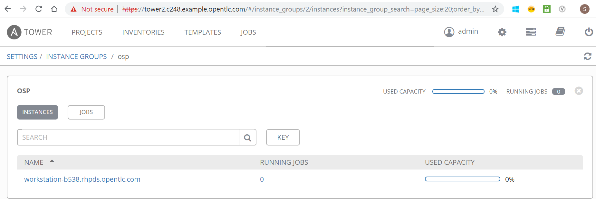

**Step 5:** Prepare the environment for 3 trier application set up:

Scripts used to create the setup: